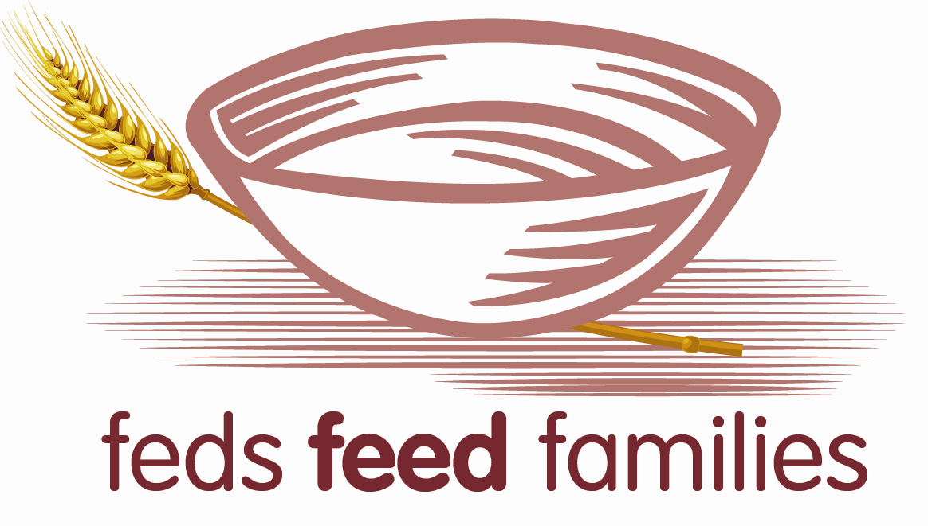 **Feds Feed Families**   **Commissary Program**

1 June to 31 August 2012

The 4th Annual Feds Feed Families summer food drive is underway! Food banks across the country are facing severe shortages of non-perishable items, just as summer begins and children are left without school nutrition programs. Federal agencies nationwide are stepping up to meet this challenge by gathering non perishable food for families in need this summer. Please help Department of Defense meet our 2012 goal of collecting 1.5M pounds of food.

**For the convenience of our eligible Commissary customers, we are offering packages of food that you may buy at the Commissary checkout. Place an “X” next to the quantity you would like to purchase. This food donation will be included in your total bill.**

* One food package (approx 10 lbs of food)
* Two packages
* Three packages
* Four packages
* Five packages

Note: Price will be approximately in the $10.00 range per package and may vary slightly based on your commissary location.

Bring this Commissary Copy Order Formto make the purchase at your local participating commissary. This form is also available online at [www.defense.gov/fedsfeedfamilies/](http://www.defense.gov/fedsfeedfamilies/)

For questions on the Commissary Program, please contact Mr. Randy Eller, 804-734-8000 x86191 or Mrs. Sylvia Ellis 804-734-8000 x48736.